|  |  |  |
| --- | --- | --- |
| Bangalore Shivacharan – CEO | David Hong – product manager | Nayanjeet Medhi |
| Jamey Money - User | Marguerite Rogers - User | JC |
| Steve Levis - User |  |  |

Feedback from User Experience demo on 6/24/2015.

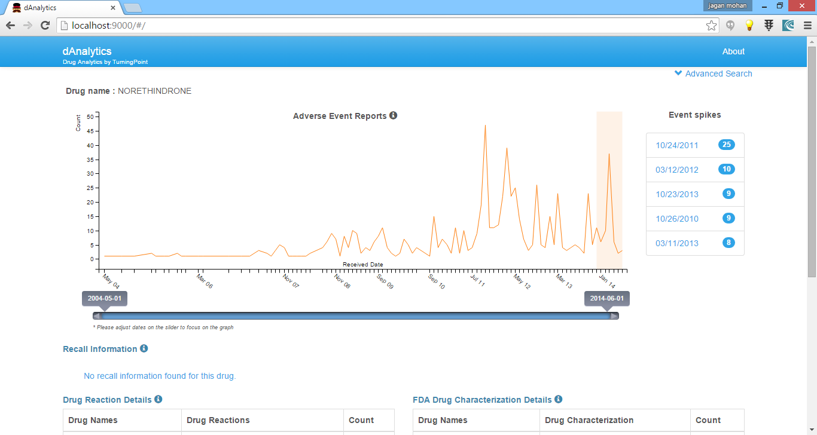

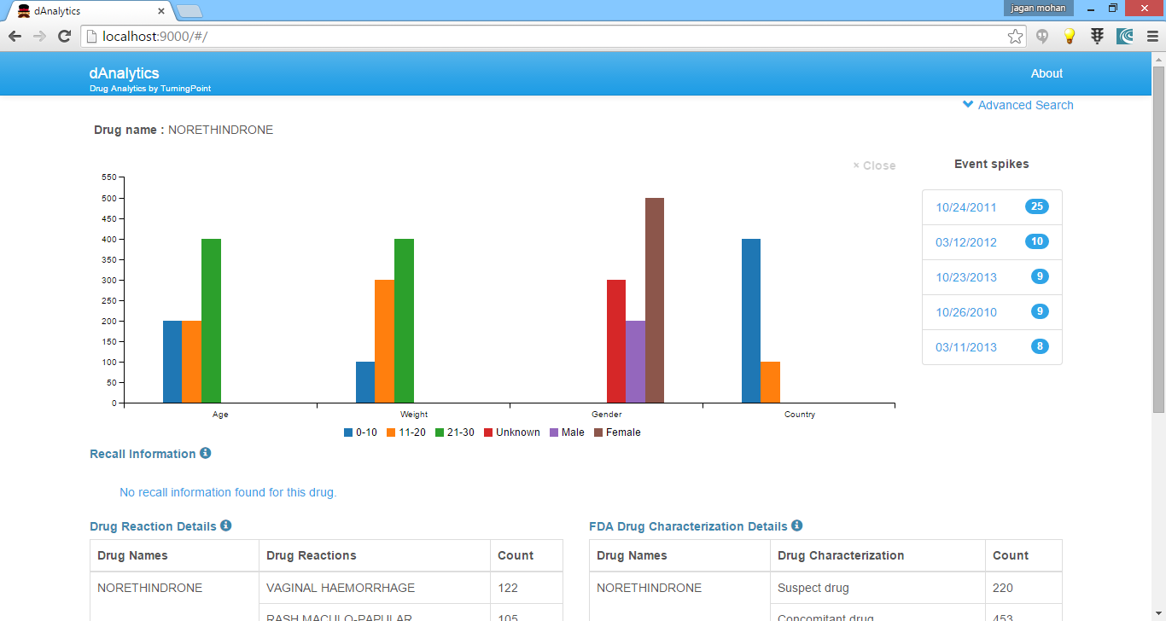

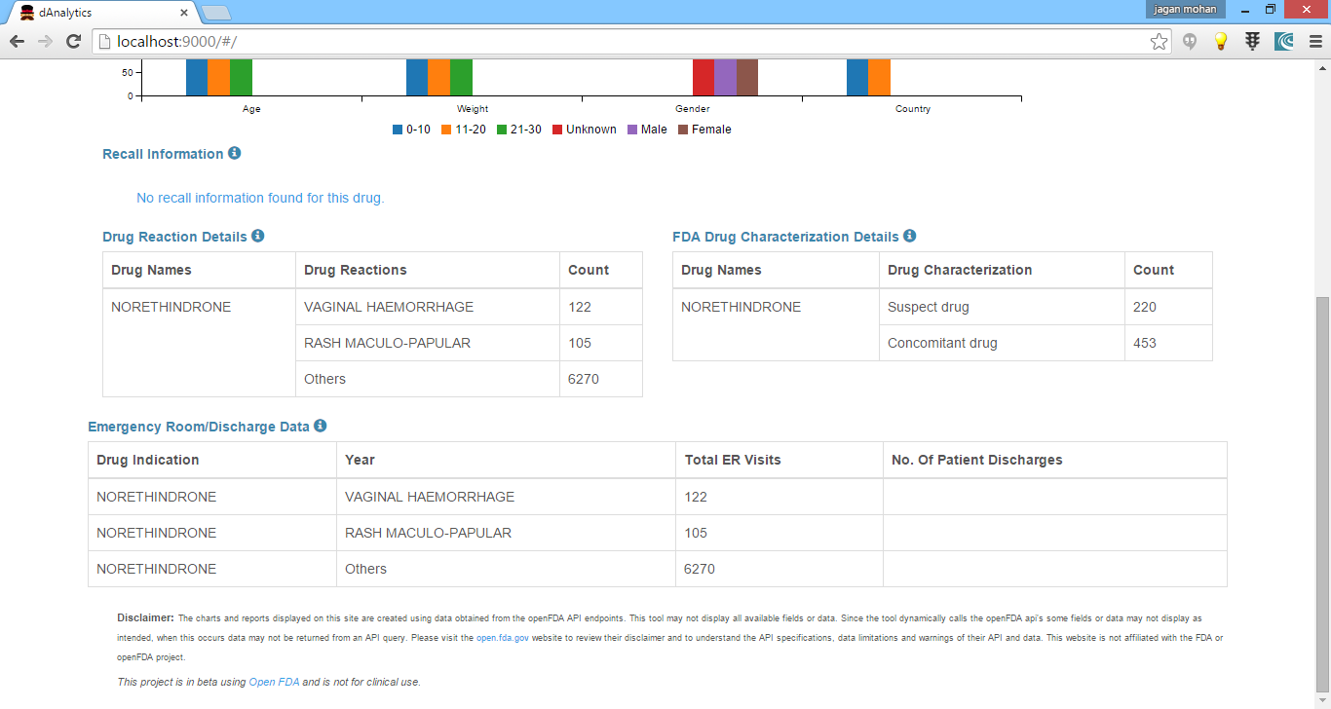

* Use the logo attached.
* Message on top portion of the page

“dAnalytics compiles drug adverse event data from the U.S. Food and Drug Administration (<https://open.fda.gov>).  We have analyzed about 10 million drug adverse events from the last 10 years, between 2004 and 2014. Search here to look for specific drug's events and related data.”

**Filter changes**

* Change Input filter criteria in single line
  + Select Drug – tooltip should be “Select a drug to see any adverse events reported for it.”
  + Select period “from place holder”  “box to place holder”
  + Gender
  + Age Group
  + Weight Range
  + Country

Radio button one – Offline Local Data – tool tip. “The report runs on local database downloaded from FDA (<https://open.fda.gov>). Select this option when open FDA.gov is not available.”

Radio button two - Online FDA Data – tool tip “Data is retrieved in real time from FDA using open FDA APIs (<https://open.fda.gov>).”

**Spike table information**

* No spike found should be --- no data found
* Fix the issue spike should be for month.
* Spikes in the list should be in descending order. Date format should mm/yyyy. Spike table name should be “ Spike(s) in adverse event”. Bottom of the table should “*for the period 2004 to 2014”.
* On click any row should open pie graphs. Both count and percentage values should be shown for each pie chart. Try out different options. Make this look good.
* Toggle button or close button should be there to come back to normal graph.

**Graph information**

* Graph line color should be “red”.
* Graph data should be only for the year 2004 to 2014.
* Message on top of the graph should be “Adverse event reported for selected drug, gender, age, weight for the period 1/2004 to 12/2014.“ default “ Adverse event report for the period 1/2004 to 12/2014”.
* Example “Adverse event reported for selected drug NORETHINGRONE, female, age group upto 20 for the period 03/2004 to 05/2014”

Table Information

* Reaction table column names - Drug Name, Drug Reaction, Number of Adverse event
* Characterization table column names - Drug Name, FDA drug Characterization, Number of Adverse event
* Bottom of the page message “Developed by TurningPoint global solution LLC for GSA agile delivery service request for the quotation – 4QTFHS150004”
* Add Turing Point Logo. Bottom right or top right.